**PIPING REPORT Page design**

General comments

* Each tab should be configurable for access control. ( ex : TML entry can be done by a group, recommendation can be another group etc. view to all)
* There should be a print option on top to print the report.
* distribution list can be a predetermined list as per plant and also user can select a personnel number/name. The link should be sent to the corresponding user in a mail.
* Approval route of the report should be configurable for each plant and should follow digital approval.
* Need further discussion about "Recommendation tab" data. Here Inspector enters the recommended action and action taker (say Maintenance) will complete the action and enter the feed back. So we need to discuss to keep these two in same tab or split into two tabs "Recommendations" and "Action Feed back".
* By default each tab will keep open if some data available. If not it will remain closed and show as only tab.

PIPE REPORT – List View

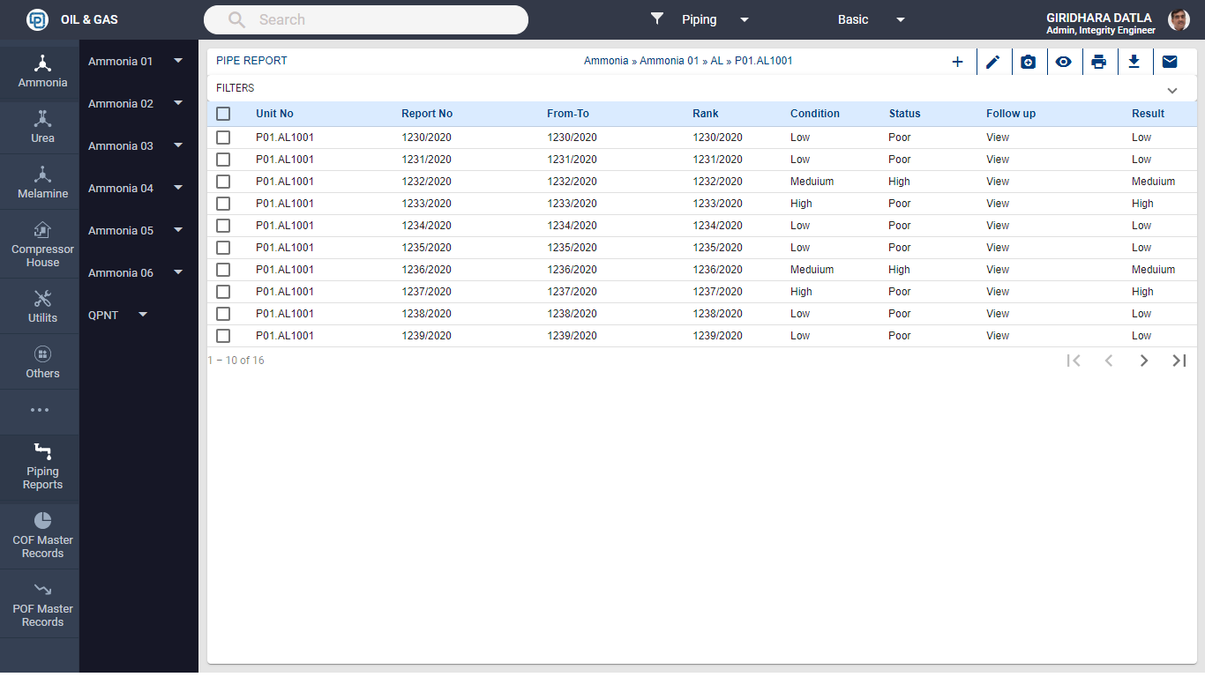

PIPE REPORT – Filters (Expanded)

Filters – Plant, Fluid, Status, Year of Inspection, Defect

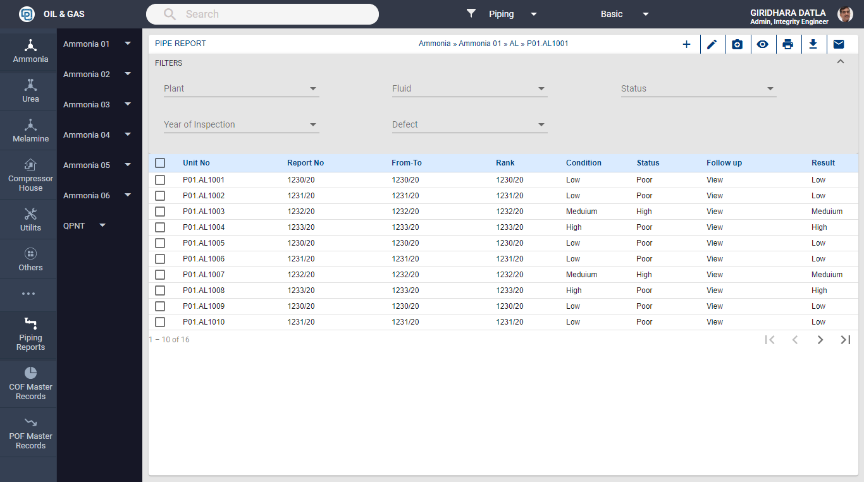

Include also Unit no , Risk, status, followup status as filters (or) just below each column name put-up a field to type and filter the data

PIPE REPORT – Add/Edit Form

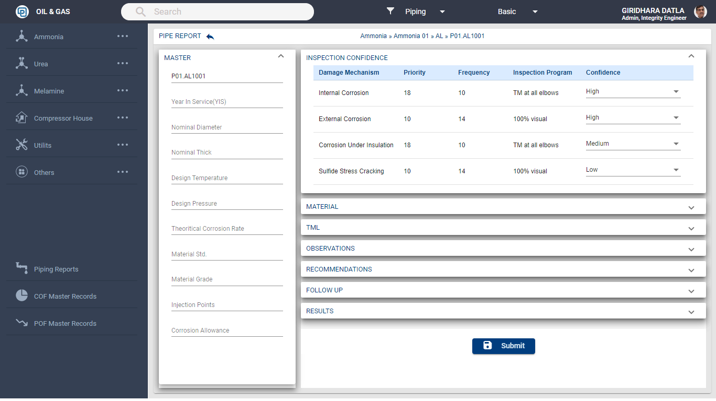

Line No: ( **user selects or type)**

**Auto from Pipe master**

Description:

From - To:

Plant:)

Consequence:

Risk:

P&ID number

Cluster Number,

Material,

Fluid,

**User Entry**

Report no: auto no /yy

Date: today date

Type of Inspection: list (user)

Overall Status: List

Revised Status:

Toatl ManHrs:

PIPE REPORT – Add/Edit Form



Provision to attach documents, photos etc

Line No: ( **user selects )**

**Auto from Pipe master**

Description:

From - To:

Plant:)

Consequence:

Risk:

P&ID number

Cluster Number,

Material,

Fluid,

**User Entry**

Report no: auto no /yy

Date: today date

Type of Inspection: list (user)

Overall Status: List

Revised Status:

Toatl ManHrs:

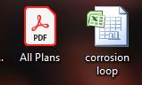

Inspection Program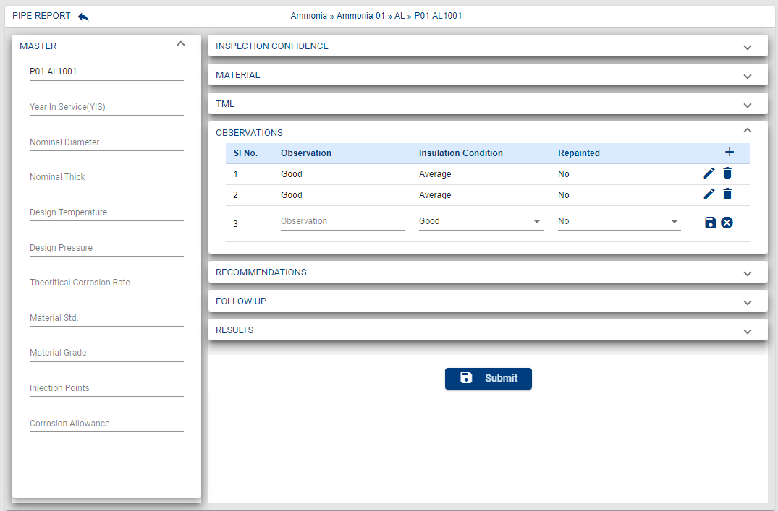

Inspection Program

Line No: ( **user selects or type)**

**Auto from Pipe master**

Description:

From - To:

Plant:)

Consequence:

Risk:

P&ID number

Cluster Number,

Material,

Fluid,

**User Entry**

Report no: auto no /yy

Date: today date

Type of Inspection: list (user)

Overall Status: List

Revised Status:

Toatl ManHrs:

This is a single column (not a table) which will be propagated from Piping master Table. There will be rows depending on the pipe master propagated data.

Inspection Program, (new tab, This will be the 1st Tab)

Inspection Confidence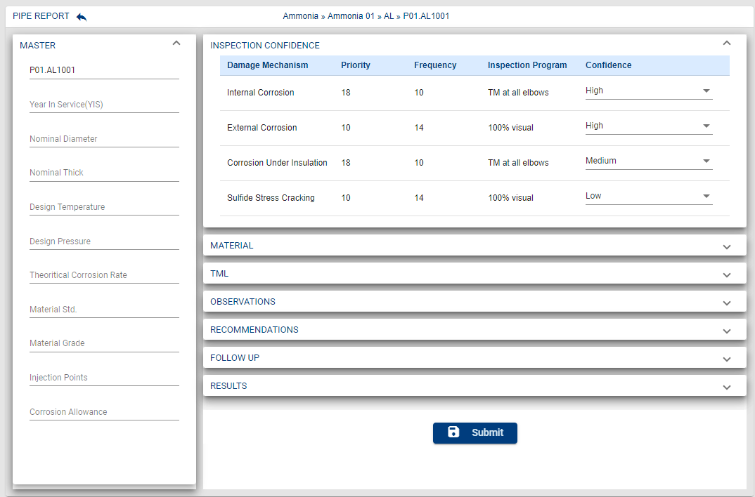

Inspection confidence tab should be after" Observations" tab

Two more columns: NDT method, last Insp Year

Reduce Size

Increase Size

Reduce Size

Material

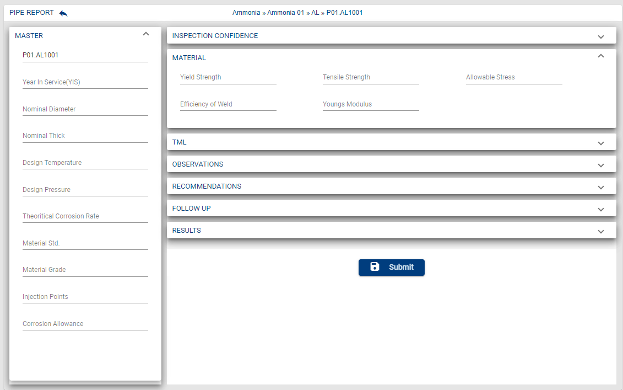

this tab is not required , instead create a CML tab as per next page

CML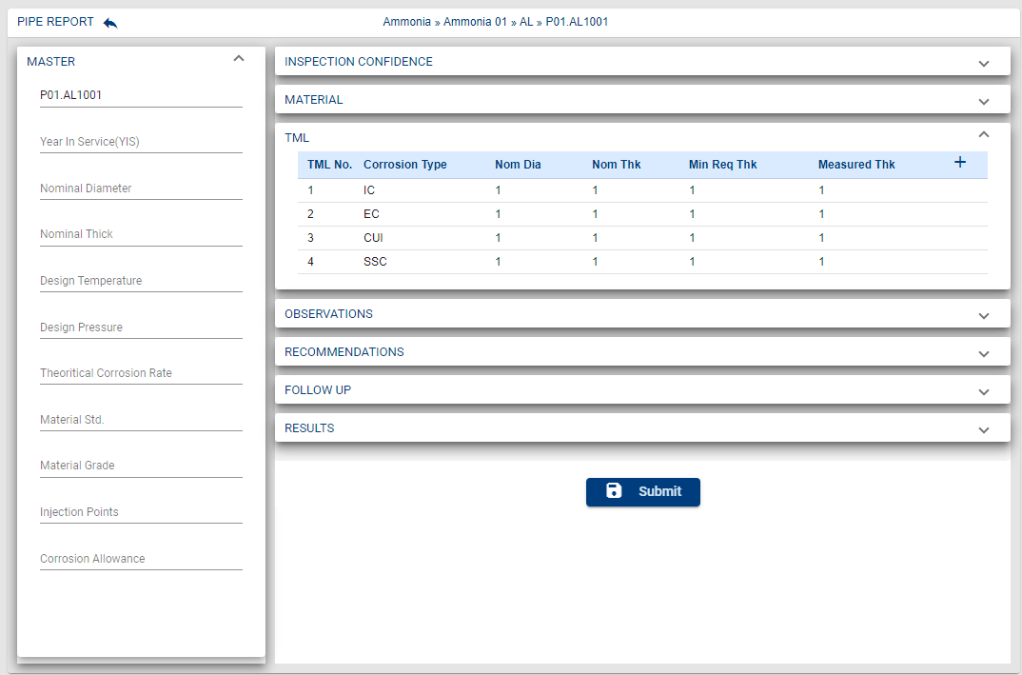

NDT technique (25) , Inspection done (150), Findings (list)

This table will start with one row and user can add as many rows as he wants

DM code

CML No

CML

TML

A button to view TML graph from Pipe master

Two more columns in the table:

Remaining life, Next Insp Date

This table will start with one row and user can add as many rows as he wants

Rep Dia (From PM): Rep Nom Thk(PM): Rep Last Measured Thk(TML): Last Measured Year(TML): Rep Measured Thk:User,

Observations

This is a single text field (not a table) to type in observations with varchar250 as one row. User can add more rows

Insulation condition (Avg/Below Avg/Good): Repainted (Y/N)

Recommendations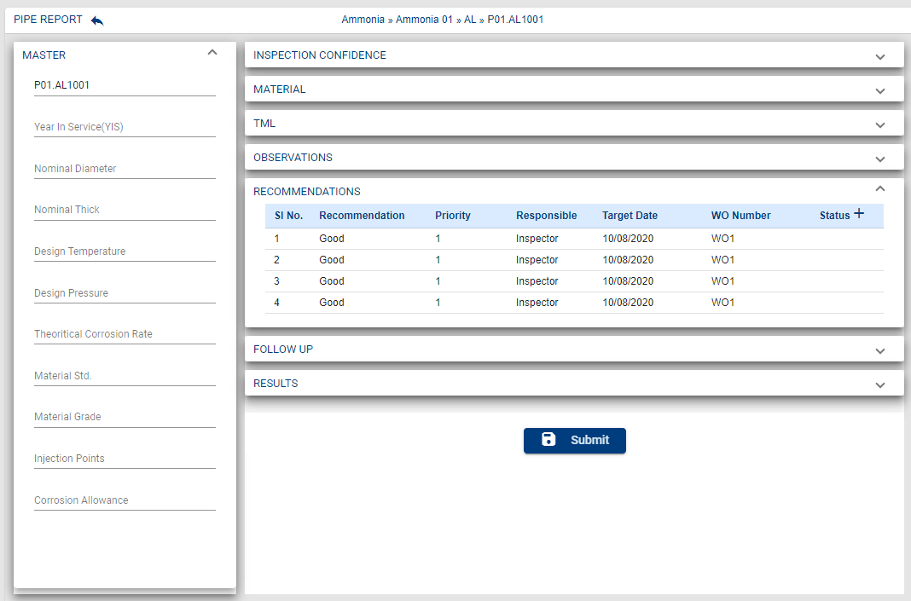

WO status

Resulted Into:

Defect Code:

Present Status:

Reduce size of all these fields to accommodate" recommendation" length or make in two rows for each recommendation to fit.

Also option to add two more field to record the "comment by action taker" (150 characters) for each recommendation and action update date..

Report no/sl no

Increase size to max (250 character)

Follow up& Results

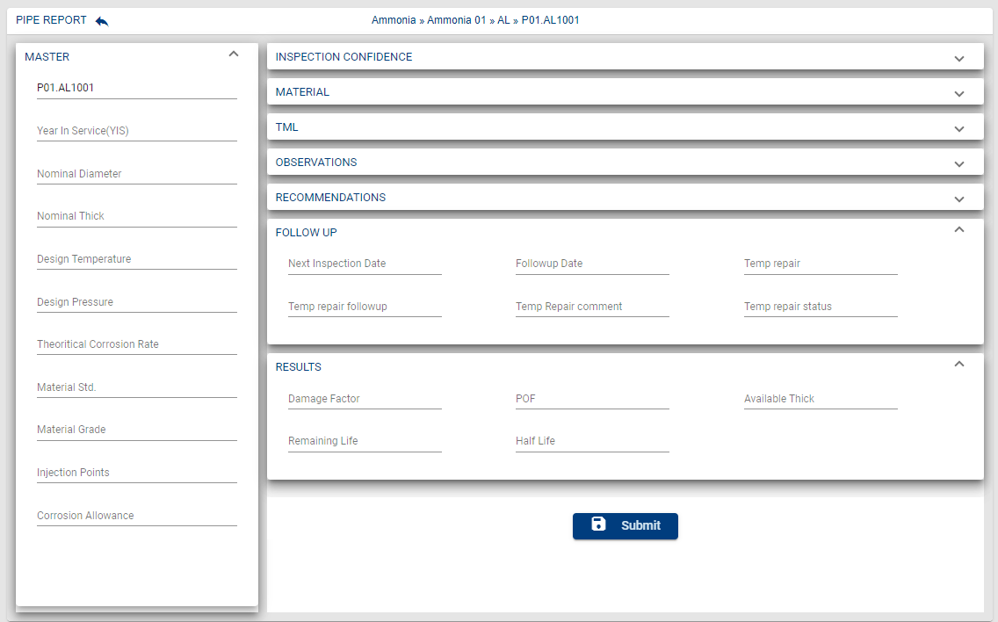

Rep Status: Working/Approved

Distribution:

1:

2: +add

Entered By:

Checked by:

Approved by:

Approval & Distribution

Next Insp date: Temp repair Y/N: requires RCA (Type): Root Cause:

Next Follow-up date

Status

Temp repair follow-up comment